The parameter selection of Spearman Correlation Coefficient (SCC) used in our network construction
In our study, differential network analyses were used to identify the candidate regulatory patterns (CRP) across multiple paths of neural stem cells differentiation. Differential network analyses are able to prioritize genes between two networks with different biological conditions (e.g. cancer versus normal). However, the identification accuracy by differential network analyses rely on robust network skeleton [1]. The unbalanced distribution of SCCs in the different networks could be result in deviating rankings of the entities leading to incorrectly derived differential centralities [2].
As such, we chose SCC=0.1 which is supported by the graphical display of the distribution of SCCs in the different networks (Supplementary Figure 1). As is shown in Supplementary Figure 1, each path contains two biological states (named as cmp and ctl in the plot), the features (mean and standard deviation) of distribution of SCCs were calculated after removing the edges with SCCs lower than threshold iteratively. To meet the requirement of balanced distribution of SCCs in the different networks in all paths, the size and color of nodes between cmp and that of ctl should be similar. Therefore, SCC=0.1 was picked up.
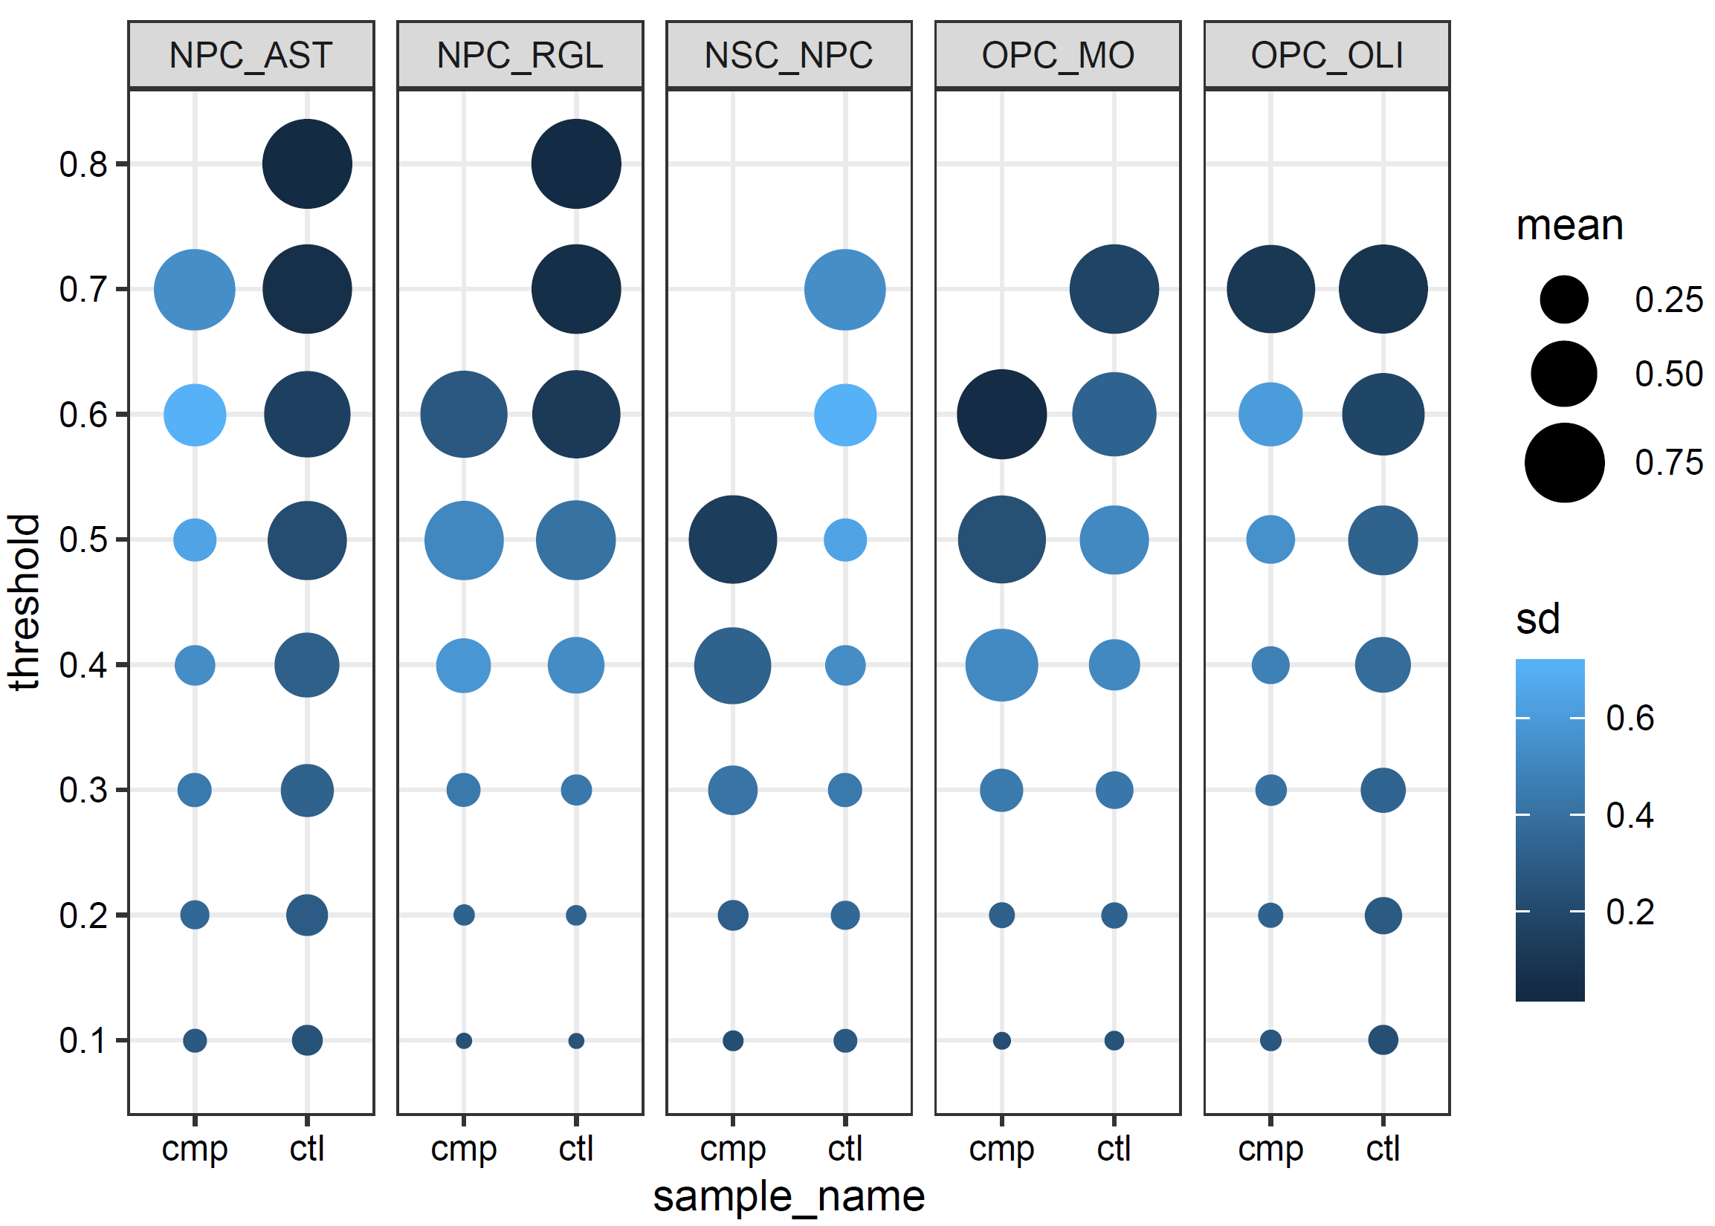
Supplementary Figure 1. The features of distribution of SCCs in the different network in five paths of neural stem cells differentiation. Each path contains two biological states (named as cmp and ctl in the plot).The mean and standard deviation of distribution of SCCs were calculated after removing the edges with SCCs lower than threshold iteratively. The size and color of nodes corresponding to mean and standard deviation of distribution, respectively.

References
1. Chasman D, Fotuhi Siahpirani A, Roy S: Network-based approaches for analysis of complex biological systems. Curr Opin Biotechnol 2016, 39:157-166.
2. Lichtblau Y, Zimmermann K, Haldemann B, Lenze D, Hummel M, Leser U: Comparative assessment of differential network analysis methods. Brief Bioinform 2017, 18(5):837-850.

